
Unit 23, Moss Lane, Royton, Oldham, OL2 6HR
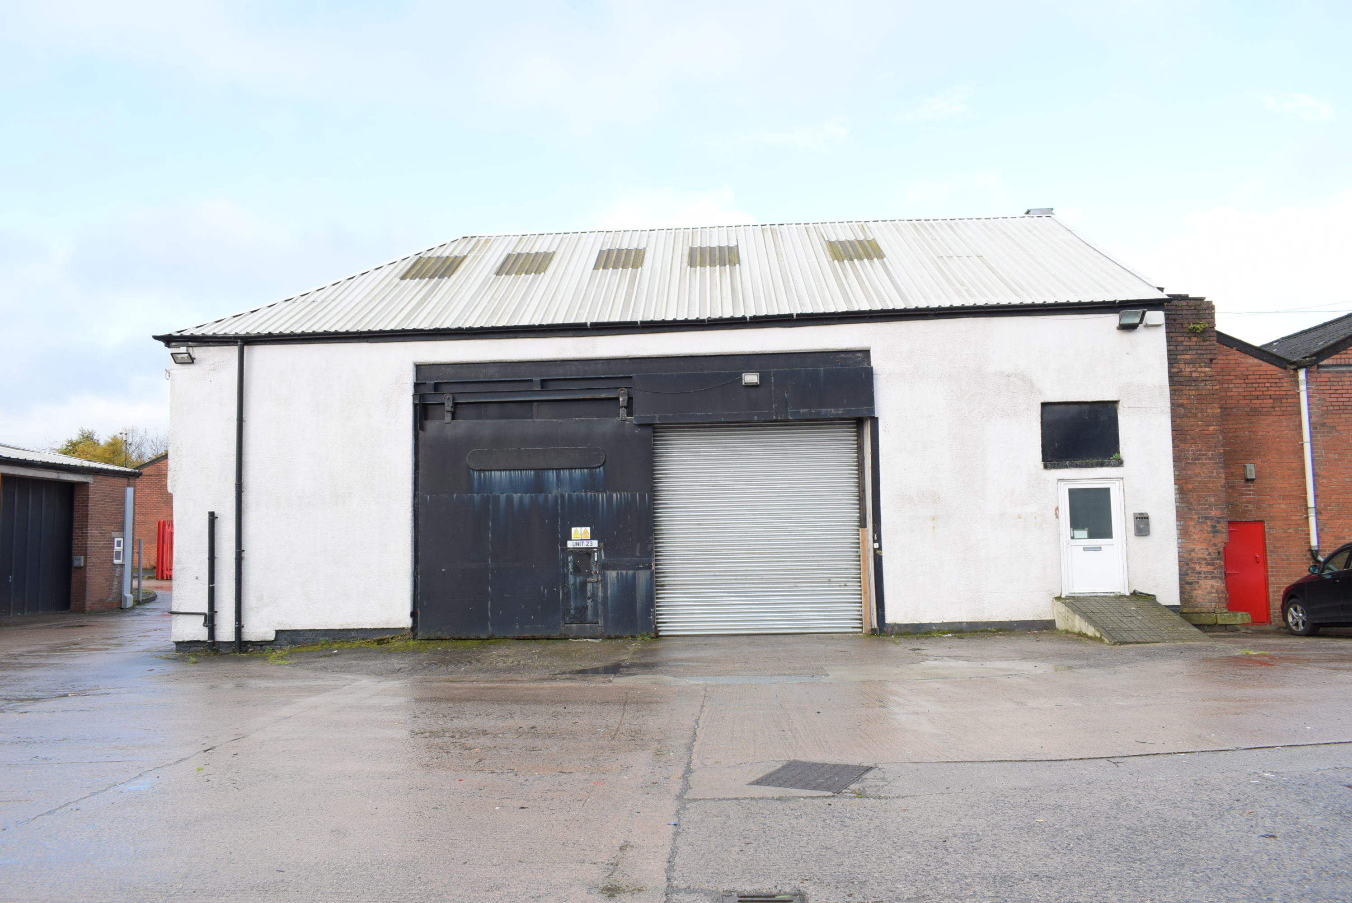
- Workshop/Warehouse Premises
- 258.97 Sq M (2,787 Sq Ft)
- Popular Trading Estate
- 24 Hour Security
- Mezzanine Level
- Shared Yard
- Vehicle Uses Not Permitted

TO LET: £19,500 Per Annum, Exclusive

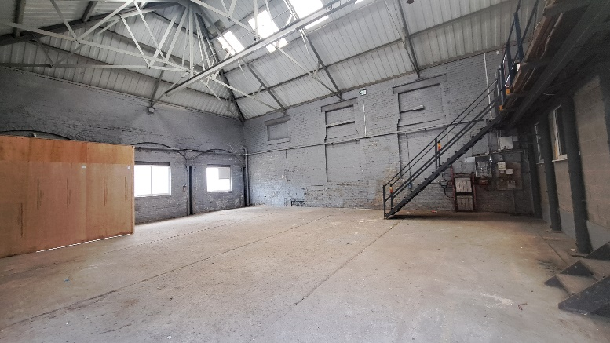
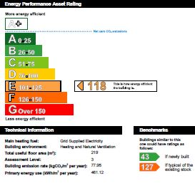

LOCATION
The property is situated off Higginshaw Lane, at its junction with Salmon Fields and Higginshaw Lane (B6194), approximately 2 miles north of Oldham town centre. The A627(M) links to junction 20 of the M62, which is within 2 miles via Broadway, and junctions 21 & 22 of the M60 are also within easy reach.

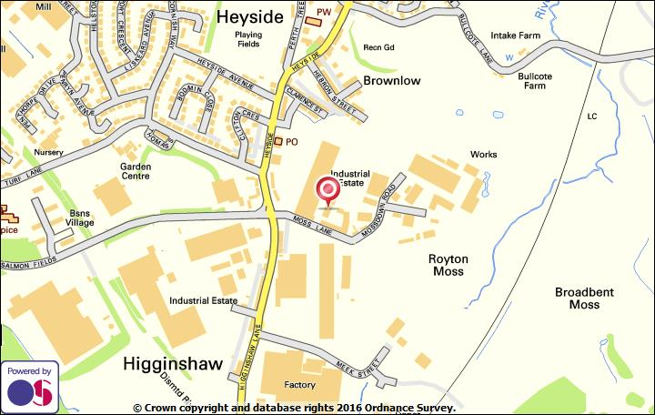

DESCRIPTION
Self contained workshop premises unit with mezzanine floor and cabin office. Goods access is via sliding door and internal roller shutter loading doors. (3.59m wide x 3.60m high). There is an electric roller shutter to the pedestrian door. Suitable for a number of business types, subject to landlord consent although vehicle uses are not permitted.

ACCOMMODATION
From measurements taken we understand that the approximate gross internal floor areas are as follows:
Ground Floor 191.31 sq m (2,059 sq ft)
Mezzanine 48.62 sq m (523 sq ft)
Office 19.04 sq m (205 sq ft)

Total 258.97 sq m (2,787 sq ft)

SERVICES
We understand that mains drainage, water and electricity are available. Prospective Tenants should make their own enquiries to confirm.

TERMS
The property is available for a term to be agreed on a full repairing and insuring basis. The Tenant will reimburse the Landlord for the cost of annual buildings insurance.

RENT
£19,500 per annum, exclusive.

SERVICE CHARGE
A service charge will be levied for the cost of maintenance repair and upkeep to the common areas of the wider estate.

LEGAL COSTS
The Tenant is to be responsible for the Landlords reasonable legal costs incurred in the preparation of the Lease documentation in this matter and an undertaking will be required.

LANDLORD & TENANT ACT 1954
The Lease will be excluded from the security of tenure and compensation provisions of Section 24-28 of the Landlord & Tenant Act 1954 Part 2 (as amended).

BUSINESS RATES
The property has been assessed for rating purposes as follows:
Rateable Value: £10,250
Uniform Business Rate: £0.546/£0.499 (2024/2025).
(Small business rates relief for eligible rate payers)
Prospective tenants must check and confirm rates payable with the Local Authority.

LOCAL AUTHORITY
Oldham MBC (T) 0161 770 3000 (W) www.oldham.gov.uk

VAT
We are informed that VAT is payable in addition to rents quoted.

VIEWING
Strictly by prior appointment with Breakey and Nuttall. Please refer to the notes section below.

NOTE:
The Code of Practice on Commercial Leases in England and Wales strongly recommends that a prospective Tenant obtains professional advice from a qualified surveyor or solicitor before agreeing and signing a business tenancy agreement.

These details are believed to be correct at the time of compilation but maybe subject to subsequent amendment. Measurements and floor areas are given as a guide and should not be relied upon. No tests have been carried out on any service installations, plant, machinery, equipment or fixtures and fittings referred to in these particulars and no warranty is given as to their condition or operation.

We have not been provided with any of the following compliance records for the property: Asbestos Management Survey & Risk Register/Annual Gas Safety Certificate/Fixed Wiring Certificate (known as an EICR)/Legionella Risk Assessment. Viewings will be at prospective tenant’s own risk.

Prospective purchasers/tenants must check and confirm rates payable with the Local Authority, the Postcode with Royal Mail and should also ensure that telecoms and mains service provision is sufficient for their purpose. Circumstances may change beyond our control after the publication of these particulars.

Subject to Lease/Contract JCN/LP/A591 (September 2024)

